Multiple-choice section – choose the correct answer

Question 1 [1.1]

A 20 g chocolate bar contains 27% sugar. If the sugar content is decreased by 10% and fibre is added to maintain the original mass, the percentage of sugar in the bar is now:

A 2.7% B 5.4% C 17% D 24.3%

Question 2 [1.2]

If an article that cost $653 now costs $812, the % profit is, correct to 2 decimal places:

A 19.58% B 24.34% C 24.35% D 80.42%

Question 3 [2.2]

The length of the hypotenuse of a right-angled triangle with two shorter sides of 12.9 mm and   
17.3 mm respectively is, correct to 2 decimal places:

A 11.53 mm B 21.58 mm C 30.2 mm D 47.57 mm

Question 4 [2.5]

Which of the following is not a Pythagorean triple?

A (15, 36, 39) B (15, 20, 25) C (15, 18, 21) D (15, 8, 17)

Question 5 [3.2]

 would simplify to:

A 2*a*5*b* B 4*a*7*b*6 C 12*a*7*b*6 D 12*a*8*b*2

Question 6 [3.6]

When simplified, 3*h*(6*d* – 4) – 5*h*(5*d* – 8) is equal to:

A 7*hd* + 28*h* B -7*hd* – 12*h* C -7*hd* – 52*h* D -7*hd* + 28h

Question 7 [3.7]

When fully factorised, the expression *-y*(2*a* + 3*b*) + 7*x*(2*a* + 3*b*) is equal to:

A (2*a* + 3*b*)(7*x* – *y*) B (2*a* – 3*b*)(7*x* + *y*) C (2*a* + 3*b*)(7*x* + *y*) D (2*a* – 3*b*)(7*x* –*y*)

Question 8 [4.1]

The perimeter of the shape shown is:

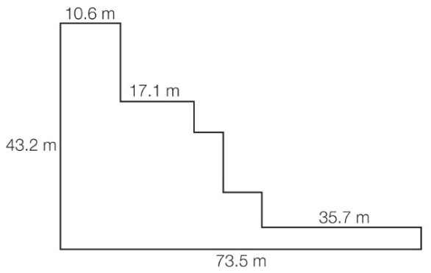

A 180.1 m B 233.4 m C 3175.2 m D cannot be found

Question 9 [4.2]

The shaded area of the shape shown is closest to:

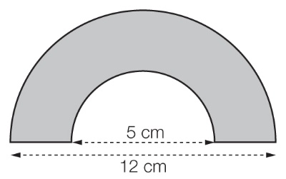

A 44 cm2 B 47 cm2 C 93 cm2 D 187 cm2

Question 10 [4.3]

The surface area of a rectangular prism with a length of 52 cm, a width of 38 cm and a height of 29 cm is closest to:

A 4586 cm2 B 9172 cm2 C 14 161 cm2 D 57 304 cm2

Question 11 [4.4]

A cylindrical water tank has a radius of 1.2 m and a height of 2.21 m. The capacity of the tank is closest to:

A 10 kL B 17 kL C 100 kL D 1 000 000 kL

Question 12 [5.1]

The equation  = -3 has the solution:

A *m* = -36 B *m* = -15 C *m* = -9 D *m* = -6

Question 13 [5.3]

The distance between (-2, -6) and (10, -1) is:

A 5 B 13 C 15 D 19

Question 14 [5.4]

Which of the following points does *not* lie on the line of equation *y* = 7 – 3*x*?

A (-8, -17) B (-2, 13) C (1, 4) D (9, -20)

Question 15 [5.6]

The equation of a linear graph with *y*-intercept (0, 4) and gradient of -5 is:

A *y* = 4*x* – 5 B *y* = -5*x* – 4 C 5*x* – *y* = 4 D 5*x* + *y* = 4

Question 16 [5.8]

The line with equation *x* = 3 has:

A a gradient of -3 B a gradient of zero C a gradient of 3 D an undefined gradient.

Multiple-choice results: ___ / 16

Short answer section

Question 17 4 marks [1.3]

In one week, Jackie worked 8 standard hours at $12.78 per hour in her part-time job, but she also worked 5 hours at time-and-a-half and 3 hours at double time. How much did she earn that week?

Question 18 3 marks [1.4]

Ali’s take home pay (net income) every fortnight is $1419.23. He pays tax of $253.85 per fortnight. What is his annual salary package (including superannuation of 9% of his gross income)? (Round your answer to the nearest dollar.)

Question 19 3 marks [1.6]

Robbie has a car loan with a bank that is charging 12.75% p.a. interest on the outstanding balance. Calculate the interest that will be charged in a 30-day month when there is a balance of $9372.07.

Question 20 4 marks [2.3]

Find *x* in the triangle shown, giving your answer:

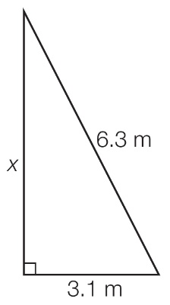

(a) in exact (surd) form

(b) in a rational approximation, correct to 2 decimal places.

Question 21 3 marks [3.1]

Simplify .

Question 22 3 marks [3.2]

Simplify , leaving your answer with positive indices.

Question 23 5 marks [3.4]

Rearrange *m(x – n) – mn = x + m* to make *x* the subject.

Question 24 4 marks [3.5]

Expand the following and simplify.

(a) (*k* + 3)*(k* –5)

(b) (3*f* –4)(4*f* – 5)

Question 25 4 marks [3.6]

Expand each of the following using a perfect square rule.

(a) (8 – *x*)2

(b) (2*x* + 3)2

Question 26 3 marks [3.6]

Expand each of the following using the difference of two squares rule.

(a) (*d* – *e*)(*d* + *e*)

(b) (3*m* + 2*n*)(3*m* – 2*n*)

Question 27 2 marks [3.7]

Factorise using common factors.

(a) 3*x –* 9*y*

(b) 4(*x* – 5) – *y*(*x* – 5)

Question 28 5 marks [3.8]

Factorise the following by grouping in pairs.

(a) *pq – rt +pr – qt*

(b) *y*2 – 8*y* + 4*y* – 32

Question 29 8 marks [4.1]

Find the perimeter of the following shapes. Give your answer correct to 2 decimal places.

(a)

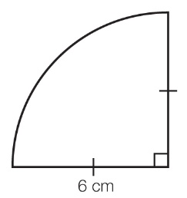

(b)

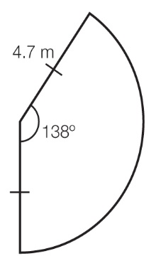

Question 30 4 marks [4.2]

Find the shaded area of the following shape, correct to 2 decimal places.

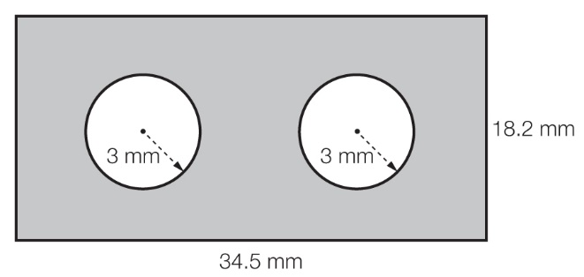

Question 31 3 marks [4.4]

Find the volume of the following solid. Give your answer correct to 2 decimal places.

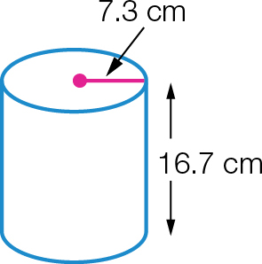

Question 32 8 marks [5.1]

Solve 3*m* + 4 = 5*m* – 2. Check your answer by substitution.

Question 33 5 marks [5.1]

A quadrilateral has angles of 3*x* – 4, 2*x* + 10, 5*x* + 27 and 8*x* – 33. Find the size of each angle.

Question 34 5 marks [5.3]

Find the midpoint of the line joining (-3, 7) and (5, 9).

Question 35 4 marks [5.4]

Complete the table of values below then plot the graph of *y* = 3*x* – 2 for -3 ≤ *x* ≤ 3.

|  |  |  |  |  |  |  |  |
| --- | --- | --- | --- | --- | --- | --- | --- |
| *x* | -3 | -2 | -1 | 0 | 1 | 2 | 3 |
| *y* |  |  |  |  |  |  |  |

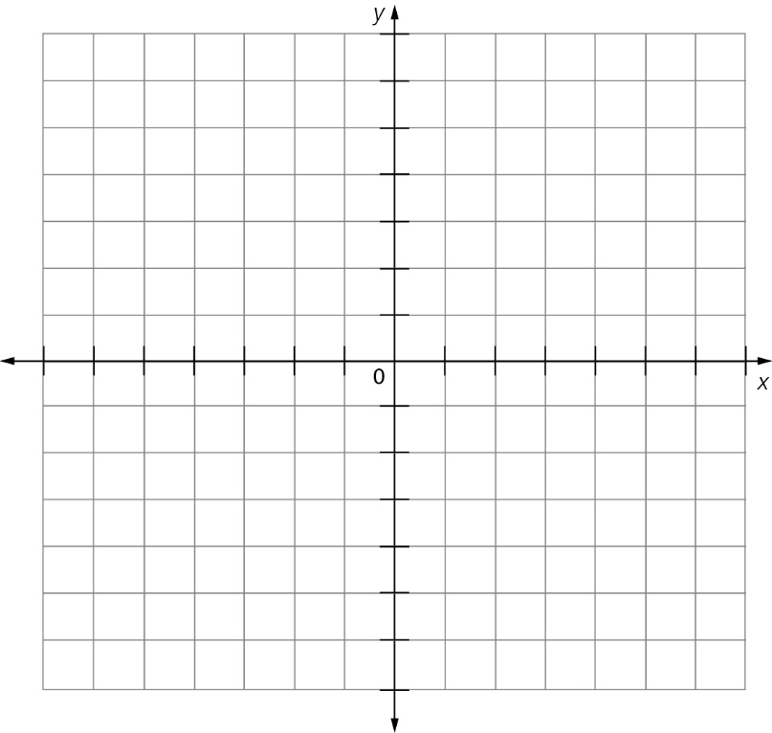

Question 36 4 marks [5.6]

Sketch the graph of *y* = 4*x* – 2 using the gradient and *y*-intercept.



Question 37 4 marks [5.7]

Sketch the graph of 3*x* – 5*y* = 15 using *x*- and *y*-intercepts.



Question 38 2 marks [5.8]

Sketch the graph of 4*x* = -8.



Short answer results: ___ / 90

Extended answer section

Question 39 7 marks [1.8]

Xiou has a prepaid mobile phone for which she pays 93c/min plus a flagfall of 30c on calls and 28c to send an SMS.

On Monday, she spent 29 minutes in total on 2 calls and sent 3 text messages.  
On Tuesday, she spent 25 minutes in total on 8 calls and sent 12 text messages.

(a) Find the cost for each day.

(b) Determine which day she spent the most money using her phone.

(c) Should she use a $59.00/month plan with a $200 cap instead? Explain your answer.

Question 40 7 marks [2.4]

A guy rope 1.6 m long is attached to the top of a vertical tent pole 1.2 m long, as shown in the following diagram. If the width of the tent at the base is 1.2 m, how far from the base of the tent can the guy rope be pegged? Answer to the nearest mm.

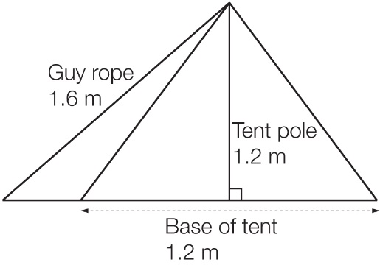

Question 41 10 marks [4.3]

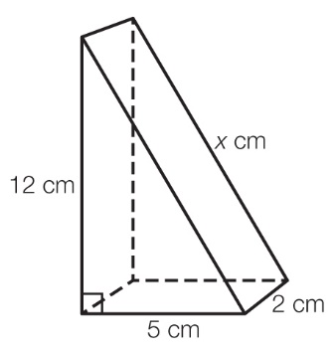

(a) Find the value of *x* in the triangular prism shown.

(b) Draw a net for the prism and use it to find its surface area.

Extended answer results: ___ / 24

TOTAL test results: ___ / 130